NetLibray eBooks - Manual
Library & Archive Services Directorate

Department of Sport, Arts & Culture
2009

CONTENTS PAGE

[Part one of Manual]:

Page

- What is an eBook 3

- NetLibrary eBooks 3

- How to Access the eBooks on NetLibrary 3

- Doing a search 5

Browsing and reading eBooks 5

------------------------------------------------------------------------------------------------

[For Part two of Manual – see separate document]:

6. Printing and Copying Text
6.1 Printing
6.2 Copying

7. Viewing multiple copies

8. All copies in use

9. Viewing Time

10. Finding help

11. Usernames and passwords

- What is an eBook

An eBook is an electronic version of a traditional printed book that you can read digitally on your computer, laptop screen or by using an eBook reader. An eBook reader can be a software application for use on a computer (such as Microsoft's free Reader application), or a book-sized computer that is used solely as a reading device. The eBook reader software used by Netlibrary is the well-known (and freely available) Adobe Reader (“PDF”-format). One of the advantages of an electronic book, compared to a normal book, is that you can easily do a quick keyword search of the whole contents (especially useful if the book’s index is not very detailed). For a good overview of eBooks go to: www.zorba.us/?page_id=818

- NetLibrary eBooks

NetLibrary is a division of OCLC (Online Computer Library Center, Inc). Through OCLC, they make use of the world’s most comprehensive database of bibliographic materials – WorldCat. In partnership with the world’s leading publishers, they provide high quality digitized, electronic content.

Selected NetLibrary eBook titles were purchased by the Free State Provincial Library Service, and are now part of our library stock (in addition, NetLibrary has a collection of free titles (which are called “Publicly-Accessible eBooks”) that can be accessed on the same website). Unlike some other eBook websites, you cannot download a whole eBook from our Netlibrary collection – you have to read the book online. You are however allowed to print/download 10 pages per hour (this limitation does not apply to the Publicly-Accessible eBooks).

- How to Access the eBooks on NetLibrary

If your library computer or office computer has access to the Intranet site of the department (Dept. of Sport, Arts, Culture Science and Technology), you don’t need a NetLibrary user account to search for or view eBooks. However, when using computers outside the Intranet, you have to log in as a remote user (see point 2 below).

There are two ways to access the eBooks on NetLibrary:

- On your library computer, or on an officer computer that have access to the Intranet site of the Dept of SACR, go to the following address: http://intranet.sac.fs.gov.za . On the left-hand side of the Intranet site is an index of links that you can click on. To access the eBooks that were bought for the stock of the Free State Directorate of Library and Archive Services, click on the NetLibrary link.

- On a computer that does not have access to the Intranet site of the Department, go to the following website: www.netlibrary.org . Enter your username and password in the login box and click on the Log in button (See picture on next page). The username and password was created beforehand and supplied to the librarian to be issued to library users on request.

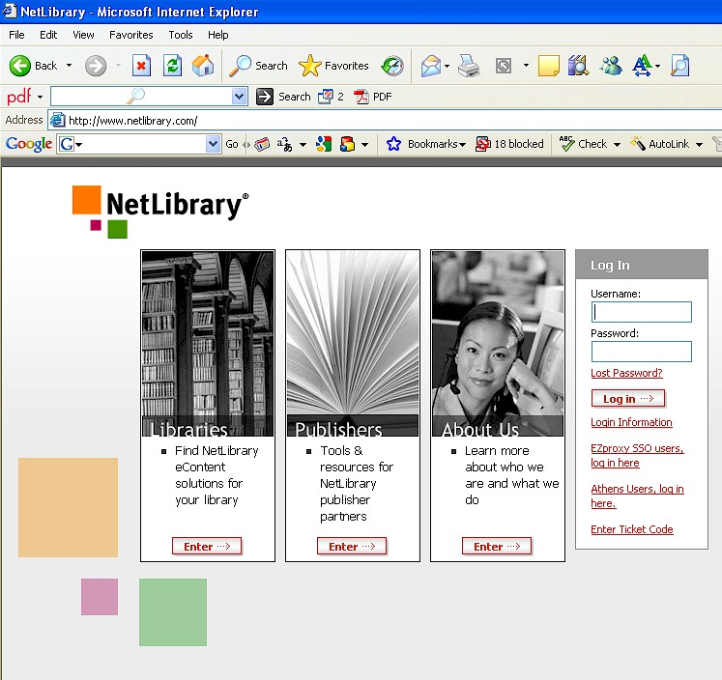

The NetLibrary link on the Intranet site as well as the Log in from the NetLibrary web site will take you directly to the correct web site (Home Page) where the icon of the Department of Sport, Arts, Culture and Recreation (small format) will be visible on the top right hand side of the screen (see below) - if you click on this icon it will take you back to the SACR Intranet site.

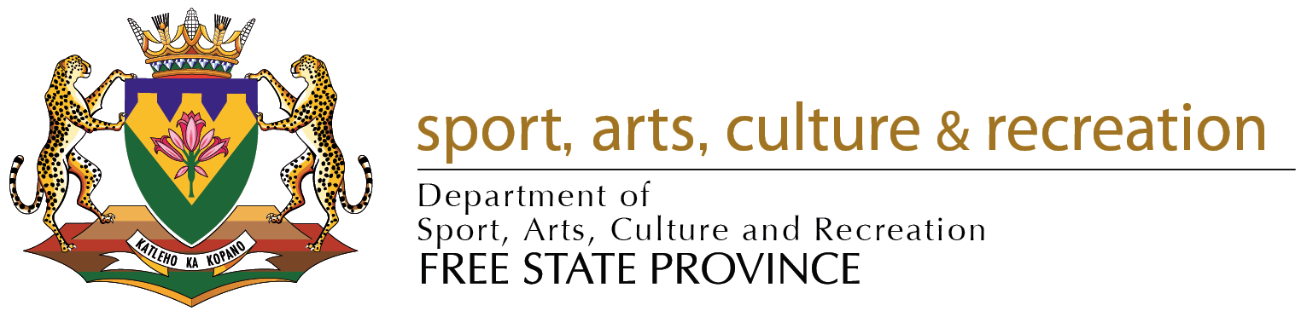
- Doing a Search

On Library Services’ Home Page of the NetLibrary site you can do a Basic Search (the Basic search is available on the Home page of our eContent Collection, and on every other page of the site), or you can go straight to the list of eBooks bought by Library Services (see point 4 below). With Basic Search, users can do a quick search by using desired search terms in one of the following search fields: Keyword, Title, Subject, Author or Full Text (the results from this search are drawn from our Library Service’s stock of eBooks, as well as NetLibrary’s collection of free items).

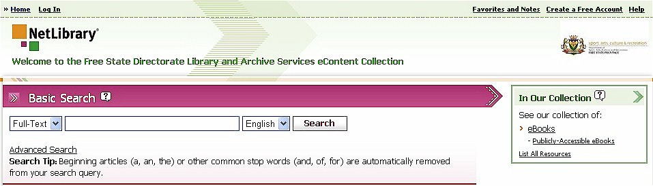

An Advanced Search is also available from the Home Page. Click on the words Advanced Search under the Basic Search area, to be taken to the Advanced Search. This search gives you the opportunity to construct more complicated searches using multiple fields ( Title, Author, Full-Text, Keyword, Publisher, Subject, and ISBN). An optional search limiter that might sometimes be useful is Year Published. Under Display Options, you can specify the manner in which the research results must be displayed (for example, newest publications first).

Browsing and Reading eBooks

Under the icon of the Department of SACR is a block with the heading: In Our Collection. Now click on eBooks to open the list of electronic books bought for our Library Services.
(note: to see the list of free eBooks from NetLibrary, click on Publicly Accessible eBooks).

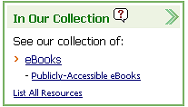

The first 15 records will be visible on the first page. To see the rest you have to turn the page by clicking on the next number or the word Next following after the numbers on the top or bottom right side of the screen.

Page: 1 2 3 4 Next

To see the bibliographic details of a specific title, click on Show details. This will give you the bibliographic information and indexed terms of the title, as well as a short extract(s) from the contents. Click on View this eBook to see the full-text version or to go back to the results, click on Back to Search Results on the right side of the screen.

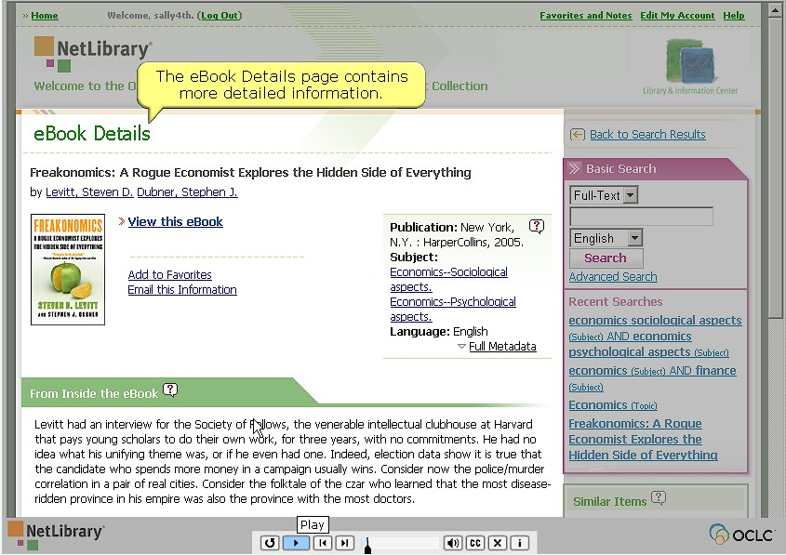

To see the full-text of a title from the results page, you should either click on the small picture of the book cover (where the cursor shows a “hand” and is thus hyperlinked) or on the words View this eBook.

Soon after you have clicked to see the full text, the book will be opened, with a contents page on the left side of the screen and the actual picture of the book on the right side of the screen. As with a normal book, all the pages of the eBook can be viewed - including the front matter (title page, etc) and back matter (index, etc).

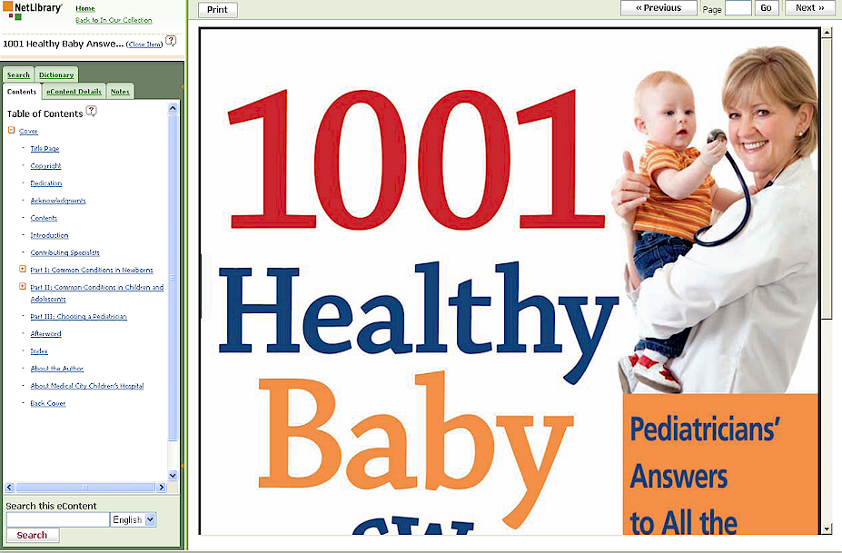

To move from the one page to the other click on the Next button on the top right-hand side of the screen, or fill in the number of a specific page. Keep on clicking to keep on reading other pages.

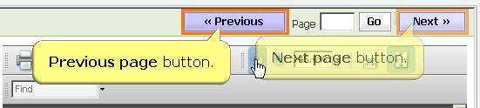

You could also use the Contents to navigate the eBook (Tip: this is a good starting point for exploring the book). On the left side of the screen, click on the heading that you want to read and you will be taken there immediately. If a heading has a square with a plus sign in front of it () you can click on it to open a sub list of sub-headings that you could also use to go to a specific section in the document.

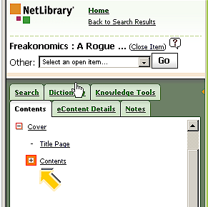

To search for a term within the book’s text you can make use of the Search Tab at the top of the Contents page area or the Search Area at the bottom of the Contents Area. Select the Search tab, enter your search term and click on the Search button.

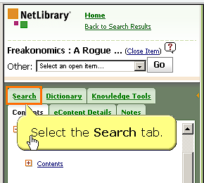

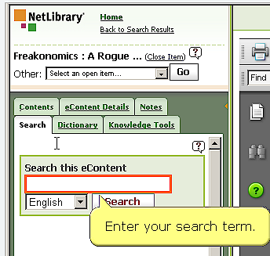
The results will appear in the form of a brief extract from the text, with the search term highlighted in the text. The page number (from where the extract was drawn) is shown in brackets. To view the page, click on View this Page.


